Amazon | OA 2020 | Amazon Fresh Promotion

LEETCODE : <https://leetcode.com/discuss/interview-question/762546/>

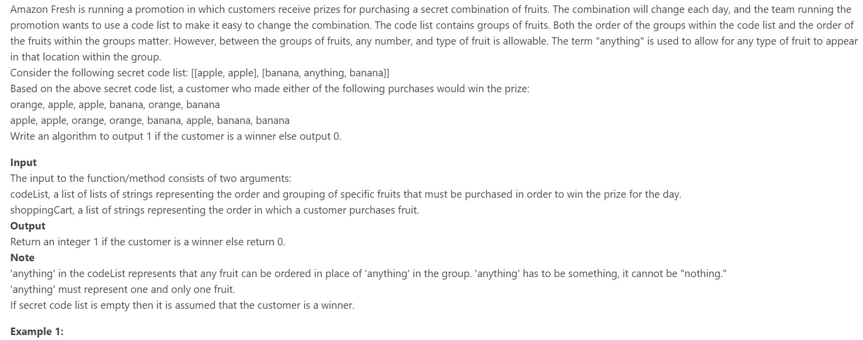

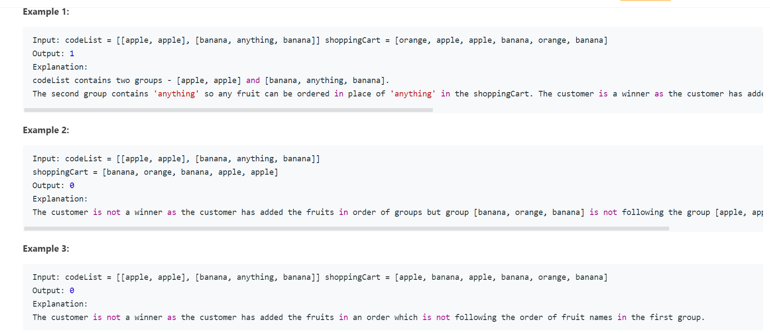

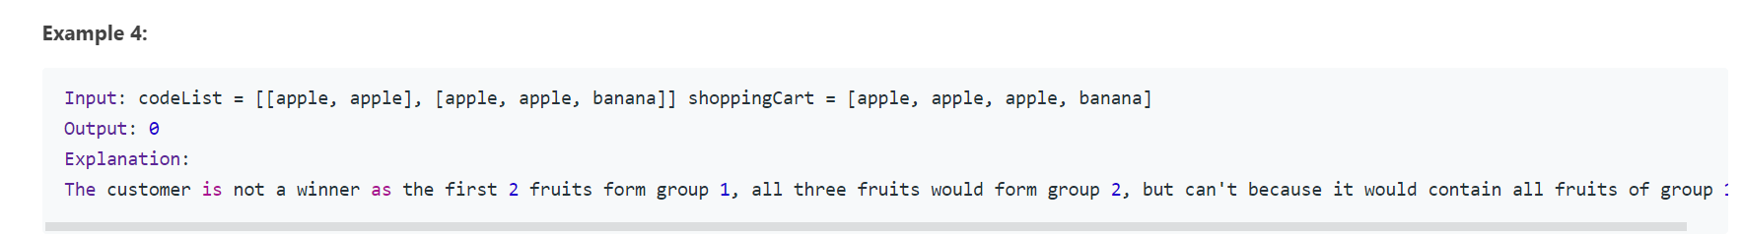

public static void main(String[] args) {

String[][] codeList1 = { { "apple", "apple" }, { "banana", "anything", "banana" } };

String[] shoppingCart1 = {"orange", "apple", "apple", "banana", "orange", "banana"};

String[][] codeList2 = { { "apple", "apple" }, { "banana", "anything", "banana" } };

String[] shoppingCart2 = {"banana", "orange", "banana", "apple", "apple"};

String[][] codeList3 = { { "apple", "apple" }, { "banana", "anything", "banana" } };

String[] shoppingCart3 = {"apple", "banana", "apple", "banana", "orange", "banana"};

String[][] codeList4 = { { "apple", "apple" }, { "apple", "apple", "banana" } };

String[] shoppingCart4 = {"apple", "apple", "apple", "banana"};

String[][] codeList5 = { { "apple", "apple" }, { "banana", "anything", "banana" } };

String[] shoppingCart5 = {"orange", "apple", "apple", "banana", "orange", "banana"};

String[][] codeList6 = { { "apple", "apple" }, { "banana", "anything", "banana" } };

String[] shoppingCart6 = {"apple", "apple", "orange", "orange", "banana", "apple", "banana", "banana"};

String[][] codeList7= { { "anything", "apple" }, { "banana", "anything", "banana" } };

String[] shoppingCart7 = {"orange", "grapes", "apple", "orange", "orange", "banana", "apple", "banana", "banana"};

System.out.println(solve(codeList1, shoppingCart1));

System.out.println(solve(codeList2, shoppingCart2));

System.out.println(solve(codeList3, shoppingCart3));

System.out.println(solve(codeList4, shoppingCart4));

System.out.println(solve(codeList5, shoppingCart5));

System.out.println(solve(codeList6, shoppingCart6));

System.out.println(solve(codeList7, shoppingCart7));

}

private static int solve(String[][] codeList, String[] shoppingCart) {

if(codeList == null || codeList.length == 0)

return 1;

if(shoppingCart == null || shoppingCart.length == 0)

return 0;

int i=0,j=0;

for(int k=0;k<shoppingCart.length;k++) {

if(codeList[i][j].equals(shoppingCart[k]) || codeList[i][j].equals("anything")) {

j++;

if(j == codeList[i].length) {

i++;

j=0;

}

if(i == codeList.length)

return 1;

}else {

j = codeList[i][0].equals("anything") ? 1: 0;

}

}

return 0;

Alternate :

The really one true good and no bad pass answer, thanks to my friend ctm

private static int isWinner(String[][] codeList,String[] shoppingCart){

//check zero length...

if(codeList == null || codeList.length == 0)

return 1;

if(shoppingCart == null || shoppingCart.length == 0)

return 0;

int i=0,j=0;

for(int k=0;k<shoppingCart.length;k++) {

//when match success

if(codeList[i][j].equals(shoppingCart[k]) || codeList[i][j].equals("anything")) {

j++;

if(j == codeList[i].length) {

i++;

j=0;

}

if(i == codeList.length)

return 1;

}else {

//when match failed, k and j both go back.

k-=j;

j=0;

}

}

return 0;

}

}